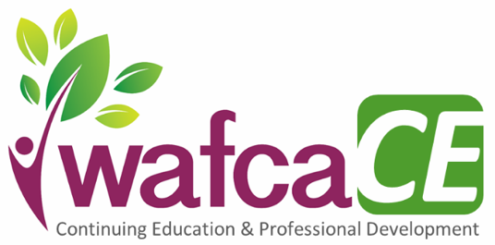

2021 WAFCA Continuing Education & Professional Development
January 22 - How to Cultivate the Skill of Well-being (GLTTC/MHTTC Partnership Workshop)
8:30 am - 12:30 pm | Presenter: Pelin Kesebir, Ph.D

February 11 & 12 - American Society of Addiction Medicine (ASAM) Criteria
Time TBD | Presenter: Saima Chauhan

March 16 - Demystifying Obsessive Compulsive Disorder (GLTTC/MHTTC Partnership Workshop)
12:30 pm – 4:30 pm | Presenter: Bradley Reimann, Ph.D

April 9 - Effectively Serving the LGBTQ+ Community (GLTTC/MHTTC Partnership Workshop)
12:30 pm – 4:30 pm | Presenter: Amney Harper, Ph.D

May 18 - A Comprehensive Response to Socio-Cultural Trauma (GLTTC/MHTTC Partnership Workshop)
10:00 am – 2:30 pm | Presenters: Patricia Parker; Dawn Shelton-Williams, MSW, LCSW

June 10 - Early Experiences Elevate Everything: Early Brain & Child Development (GLTTC/MHTTC)
8:30 am - 12:30 pm | Corina Norrbom, MD; Dipesh Navsaria, MD; Abbi Kruse; Rob Grunewald

July 13 & 15 - Psychopharmacology and Alternatives for Mental Health Disorders (GLTTC/MHTTC)
10:00 am - 12:00 pm | Presenter: David Mays, Ph.D

August 10 - Change & Acceptance in Youth Work: Applying DBT Principles (GLTTC/MHTTC)
9:00 am - 1:30 pm | Presenter: Jennifer Muehlenkamp, Ph.D

September 20 - Honoring Veteran Culture (GLTTC/MHTTC Partnership Workshop)
Time TBD | Presenters: Mathew Lindsay, MSW; Michelle Kamin-Lindsay, MSW

October 6 & 7 - Effective Supervision: Ethics and Skills for Enhanced Competence (GLTTC/MHTTC)
9:00 am - 12:00 pm | Presenter: Carol Falendar, Ph.D

November 10 - Foster Care and Adoption-Competent Practice (GLTTC/MHTTC Partnership Workshop)
10:00 am - 12:00 pm | Presenter: Michelle Robertson, MSW, LGSW

December TBD - Serving Individuals with Disabilities (GLTTC/MHTTC Partnership Workshop)

→ See wafca.org/CE-2021 for info & to register (or use the QR code)!

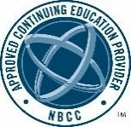
Continuing education hours are being offered for all listed 2021 WAFCA-CE sessions. WAFCA has been approved by NBCC as an Approved Continuing Education Provider, ACEP No. 6778. Programs that do not qualify for NBCC credit are clearly identified. WAFCA is solely responsible for all aspects of the programs. Visit the WAFCA-CE registration page for more information on fees and policies.

